# **MINI PROJECT REPORT**

on

## **Nearest Hospital System**

Submitted in partial fulfillment of requirements to

**CB 352 Mini Project**

**III/IV B. Tech CSBS (V Semester)**

By

Y21CB008 – CH.SAMBA SIVA

Y21CB017 – J.GEETHA HARSHITHA

Y21CB054 – S.SAI SRIKAR



**November 2023**

# **Department of Computer Science and Business System**

**R.V.R & J.C. COLLEGE OF ENGINEERING**

#### **(AUTONOMOUS)**

**(Approved by A.I.C.T.E) NAAC ‘A+’ Grade (Affiliated to Acharya Nagarjuna University) Chandramoulipuram: Chowdavaram**

**GUNTUR – 522 019**

# **R.V.R & J.C. COLLEGE OF ENGINEERING**

### DEPARTMENT OF

COMPUTER SCIENCE & BUSINESS SYSTEMS



#### **BONAFIDE CERTIFICATE**

This is to Certify that this Mini Project work entitled **“Nearest hospital System”** is the bonafide work of **Ch.Samba Siva (Y21CB008), J.Geetha Harshitha (Y21CB017), S.Sai Srikar (Y21CB054)** of **III/IV B.Tech** who carried the work under my supervision, and submitted in the partial fulfilment of the requirements to **CB352 - MINI PROJECT LAB REPORT** during the year 2023-2024.

|  |  |  |
| --- | --- | --- |
| **Mr. M. Srinivasa Rao** | **Mr. P. Srinivasa Rao** | **Dr. M. V. P. Chandra Sekhara Rao** |
| (Project Guide) | (Project Incharge) | (Prof. & Head, Dept. of CSBS.) |

**ABSTRACT**

The Nearest Hospital System (NHS) is a cutting-edge geospatial programmed that optimizes and streamlines emergency healthcare services. Rapid access to the nearest healthcare institution is critical in times of medical crisis to ensure quick and effective treatment. The NHS uses advanced geographic information systems (GIS) and real time data integration to give customers reliable, up-to-date information on surrounding hospitals, such as their specialties, available services, and current occupancy levels. The Nearest Hospital System addresses this critical need by amalgamating advanced geolocation services, hospital databases, and user-centric interfaces to swiftly provide users with information about the closest healthcare facilities. This interface delivers a seamless user experience, presenting users with a clear list of the nearest hospitals, including distance metrics, location information. Utilizing GPS technology and geospatial data, the NHS accurately determines the user's current location, enabling the system to identify the closest hospitals and healthcare facilities. This system stands at the intersection of technology and healthcare, streamlining the process of connecting individuals with urgent medical assistance and emerges as a pivotal technological asset in emergency healthcare, providing an agile and user-centric solution for connecting individuals with the closest and most suitable medical assistance in critical moments.

**ACKNOWLEDGEMENTS**

From the idea to the act, from the conception to reality, from the emotion to the response, from the desire to the spasm, we are led by those about whom to write all words seem meek.

We are very much thankful to **Dr. Kolla. Srinivas, Principal of R.V.R. & J.C College of Engineering**, Guntur, for allowing us to work on this project.

We express our sincere thanks to **Dr. M.V.P. Chandra Sekhara Rao, Professor and Head, Department of Computer Science and Business Systems** for encouraging and supporting us to carry out this project successfully.

We are very glad to express our special thanks to **Mr. M. Srinivasa Rao, Mentor** who has inspired us to select this project according to our choice and for his valuable advice to work on this project.

This Mini Project wouldn’t be completed without the help of my friends, family members and other people who are directly or indirectly connected with this work. I also express my sincere thanks to the **Technical** and **Non-Technical staff** and **all the faculty of the department** for their valuable help.

CH. SAMBA SIVA(Y21CB008)

J. GEETHAHARSHITHA(Y21CB017)

S.SAI. SRIKAR (Y21CB054)

**CONTENTS**

**Chapter No. & Name Page No.**

1. Introduction 1

1.1 Literature

1.2 Methodolgy

1.3 System analysis

2.Block Diagram & Explanation 6

2.2 Uml diagram

2.3 Activity diagram

2.4 Class diagram

3.Implementation 11

4.Result 13

4.1 Search Hospital by Location

4.2 Admin Login

4.3 Admin Home Interface

4.4 Add New User

4.5 Show All Hospitals

4.6 Add Hospital

4.7 Update Hospital

4.8 Delete Hospital

5.Social Impact 18

6.Applications 19

7.Conclusion 20

8.References 21

**List of Figures**

**Fig no.& Name Page No.**

2.1 Block diagram 6

2.2 Use case diagram 8

2.3 Activity diagram 9

2.4 Class diagram 10

3 Implementation 11

4.1 Search hospital by location 13

4.2 Admin login 14

4.3 Admin interface 14

4.4 Add new user 15

4.5 Show all hospitals 15

4.6 Add new hospital 16

4.7 Update hospital 16

4.8 Delete hospital 17

**INTRODUCTION**

The hospitality industry is a vast and rapidly growing sector that requires efficient management to deliver exceptional customer service and experience. To streamline the process of managing a hospital, a Nearest Hospital System has been developed using HTML, Reactjs and CSS. The system is designed to automate and simplify the process of managing a hospital by providing an intuitive user interface for managing hospital, adding a new user, show all hospitals, add hospital, delete hospital and update hospital. With this system, hospital admins can efficiently manage their hospital operations, improve customer service. In times of medical emergencies, swift access to healthcare facilities can be crucial. The Nearest Hospital System is a technological solution designed to provide users with quick and efficient information about the closest hospitals based on their geographical location. This system integrates geolocation services, hospital databases, and user-friendly interfaces to offer a seamless experience for those in need of urgent medical assistance. In essence, the Nearest Hospital System stands as a vital tool in emergency healthcare, leveraging technology to connect individuals with the nearest and most appropriate medical assistance.

**Literature**

It looks that the Nearest Hospital System (NHS) is an inventive way to combine healthcare services with geospatial technology. You can look through relevant literature in a number of fields, even though there may not be any published papers or specific literature available on this particular system because of its possible novelty or proprietary nature.

**Geospatial Technology in Healthcare:** Books or research articles that cover how real-time data, GPS, and GIS are integrated into healthcare systems. These could address subjects like emergency response systems, location-based services, and the use of geographic analysis in healthcare planning.

**Medical Information Systems:** Works that discuss the planning, execution, and efficiency of medical information systems that give priority to prompt access to medical facilities in an emergency. This may include database administration, system integration, and user interfaces.

**Emergency Healthcare Services:** Publications aimed at maximising the provision of emergency medical care, speeding up response times, and improving patient outcomes. Studies on patient navigation, emergency room management, and triage systems may fall under this category.

**User-Centric Design:** Resources addressing the value of user-friendly interfaces and the user experience in healthcare systems are categorised as user-centric design. This could include usability testing, user-centred design, and human-computer interaction concepts.

**Methodology**

**Technology Integration:**

**Geospatial Technology:** Implementing Geographic Information Systems (GIS) for mapping and analysing spatial data, allowing accurate identification of hospital locations in relation to user positions.

**GPS and Location Services:** Utilizing GPS technology to pinpoint user locations accurately and enable the system to identify the nearest healthcare facilities.

**Database Management:**

**Hospital Database Integration:** Structuring a comprehensive database of hospitals, including information on specialties, available services, operating hours, contact details, and real-time occupancy status.

**Data Maintenance:** Implementing protocols to maintain the accuracy and relevancy of hospital information regularly.

**User-Centric Design:**

**Intuitive Interface:** Designing a user-friendly interface that offers clear and concise information about the nearest hospitals, including distance metrics, location details, and available services.

**Accessibility:** Ensuring the system is accessible across various devices and platforms for ease of use during emergencies.

**Security and Reliability:**

**Data Security:** Implementing robust security measures to protect sensitive user and hospital data within the system.

**Reliability:** Ensuring the system operates consistently and reliably, even under high user demand or critical situations.

**System analysis**

**Existing system:**

**Description:**

The existing system of nearest hospital system operates on a single-section basis having aspects of data source, integration, mobile application and user interface. This type of system is particularly valuable in emergency situations where immediate medical attention is required. Here's a detailed description of a nearest hospital system.

**Aspects**:

**Data source:** In the existing system the data that is present is a fixed data only. That is only a limited amount of data is available in the database and only small amount of hospitals are available when the user search for a specific hospital details it may or may not be available in the databse.

**Integration:** Integrating a nearest hospital system involves connecting various components and technologies to make the system functional. The integration between the other systems is not in a wide range and only limited services are available.

**Mobile Application:** Creating a nearest hospital mobile application involves designing an intuitive user interface and integrating various functionalities to provide users with quick access to information about the closest hospitals. In the existing nearest hospital system it doesnot have a proper mobile application.

**User interface**: Designing a user interface (UI) for a nearest hospital system involves creating a user-friendly and intuitive experience for users to find and access information about nearby hospitals. In the existing nearest hospital system there is no proper user interface and also there are no standard deployment methods that are used in the system.

Regular database maintenance and performance monitoring are also crucial for optimal system functioning. Whereas, in this existing system there is no proper data or enough service that is required for the system and there is no proper data that the user can receive when they request. So by taking all these into the consideration we proposed more data into the system data base for more information about the nearest hospital system for both the user and also the admin that manages the system.

**Proposed system:**

**Description:**

A Nearest Hospital System is a technology-based solution designed to help individuals quickly locate and access information about nearby hospitals. The system typically integrates with mapping and geolocation services to provide real-time data on hospital locations, services offered, contact details, and other relevant information. The primary goal is to assist users in finding the closest medical facilities based on their current location or a specified address.

**Aspects:**

**Data source:** Regular updates and maintenance procedures should be in place to reflect changes in hospital information. In this proposed nearest hospital system there is real-time data integration that is obtained from many other multiple sources. So that the data sources can contribute to the system's overall accuracy and reliability.

**Integration:** Integrating a Nearest Hospital System involves connecting various components to provide a seamless and functional user experience. Integrating these components requires a coordinated effort there is a seamless integration with more health records monitoring and updates are essential to ensure the system remains accurate.

**Mobile application**: Nearest Hospital System involves designing a user-friendly interface, integrating key functionalities, and ensuring seamless performance. Regular updates, feedback collection, and maintenance are crucial for the success of the application. For the system we have dedicated a mobile application for easy access and navigation.

**User interface:** To prioritize a clean and user-friendly design, with a focus on simplicity and easy navigation. Conducting usability testing to ensure that the UI meets user expectations and provides a positive overall experience. This has a user-friendly interface which is enhanced with the deployment strategies.

A Nearest Hospital System is a digital solution designed to assist individuals in quickly finding information about nearby hospitals and healthcare facilities. The system typically leverages technologies such as geolocation, mapping, and real-time data integration to provide users with relevant details about hospitals in their vicinity. It combines technology, data integration, and user interaction to provide a valuable service to individuals seeking medical assistance.

**Block Diagram& Explanation**

The block diagram represents the three main components of the Nearest Hospital System, which are the user interface, the Nearest Hospital System backend, and the database management system.

The user interface provides a graphical interface for users to interact with the system. The user interface is designed to be intuitive and user-friendly, allowing users to easily perform operations such as searching the nearest hospitals, Psychiatry, Gynaecology, etc.

The Nearest Hospital System backend is responsible for processing and handling all user requests. It is designed to provide the necessary functionalities for the user interface to interact with the database management system. The backend processes requests from the user interface, retrieves information from the database management system, and generates appropriate responses.

+ - - - - - - - - - - - - - - - - - - - - - - +

| User Interface |

+ - - - - - - - - - - - - - - - - - - - - - - +

|

V

+ - - - - - - - - - - - - - - - - - - - - - - - - - - - - - - - - - - - - - - - - - - - +

| Nearest Hospital System Backend |

+ - - - - - - - - - - - - - - - - - - - - - - - - - - - - - - - - - - - - - - - - - - - +

|

V

+ - - - - - - - - - - - - - - - - - - - - - - - - - - - - - - - - - +

| Database Management System |

+ - - - - - - - - - - - - - - - - - - - - - - - - - - - - - - - - - +

The database management system is responsible for storing all the necessary data required for the nearest hospital system to function. This includes the name of the hospitals available in that particular location, also the address of the hospitals. The database management system is designed to provide secure storage and efficient retrieval of data.

Together, these components provide a complete solution for managing a hospital. The user interface provides an intuitive and user-friendly experience, the backend processes requests and generates appropriate responses, and the database management system provides secure storage and retrieval of data. This block diagram shows the basic architecture of the Nearest Hospital System and how the various components work together to deliver a comprehensive nearest hospital solution.

When a user makes a request, the user interface sends the request to the backend for processing. The backend processes the request and generates a response that is sent back to the user interface. The backend has various functionalities such as location of the hospital, name of hospital and address of the hospital.

The backend interacts with the database management system to manage data related to the hospital. This includes information such user information, hospital lists. The database management system stores this information securely and efficiently, making it easily accessible to the backend.

Together, these components provide a complete solution for managing a hospital. The user interface provides an intuitive and user-friendly experience, the backend processes requests and generates appropriate responses, the database management system provides secure storage and retrieval of data, and the reporting component generates insights that can help hospital admins make informed decisions.

**Usecase diagram**

A use case diagram in the Unified Modelling Language (UML) is a type of behavioural diagram defined by and created from a Use-case analysis. Its purpose is to present a graphical overview of the functionality provided by a system in terms of actors, their goals (represented as use cases), and any dependencies between those use cases. The main purpose of a use case diagram is to show what system functions are performed for which actor. Roles of the actors in the system can be depicted. Each actor interacts with the system through specific use cases, depicting how the system functions in response to external stimuli.

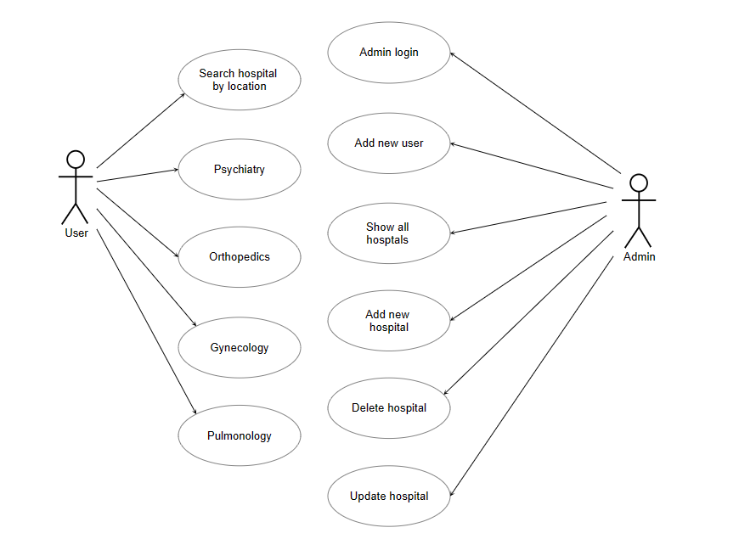

**Activity diagram**

An activity diagram visually represents the workflow of a system, focusing on the sequence of activities and actions that take place. This activity diagram illustrates the sequence of actions a user might take when using the Nearest Hospital System, from initiating a search to accessing detailed information about hospitals and utilizing emergency services. The below activity diagram is the simple diagram that shows the step by step activity of the admin role in the nearest hospital system.

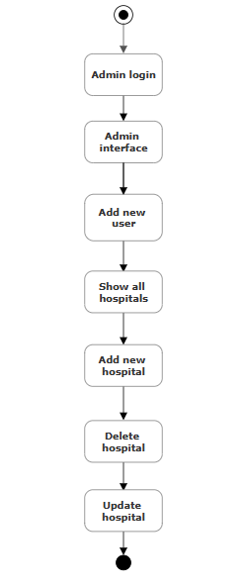

**Class diagram**

Creating a class diagram for a nearest hospital system involves identifying the main classes, their attributes, and the relationships between them. In the nearest hospital system we mainly focused on admin interface and the main role of the admin in the system. This is a basic representation, and depending on the specific requirements of our nearest hospital system, considering incorporating error handling, security features, and other relevant functionalities based on your system's needs.

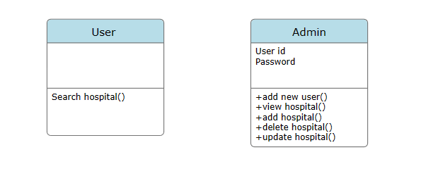

**Implementation**

Creating an automatic timetable involves designing a system or algorithm that can efficiently schedule events or activities based on various constraints and requirements. To streamline the process of managing a hospital, a Nearest Hospital System has been developed using HTML, Reactjs and CSS. The goal is to optimize the use of resources and meet specified criteria while minimizing conflicts and overlaps.

**Code screenshots:**

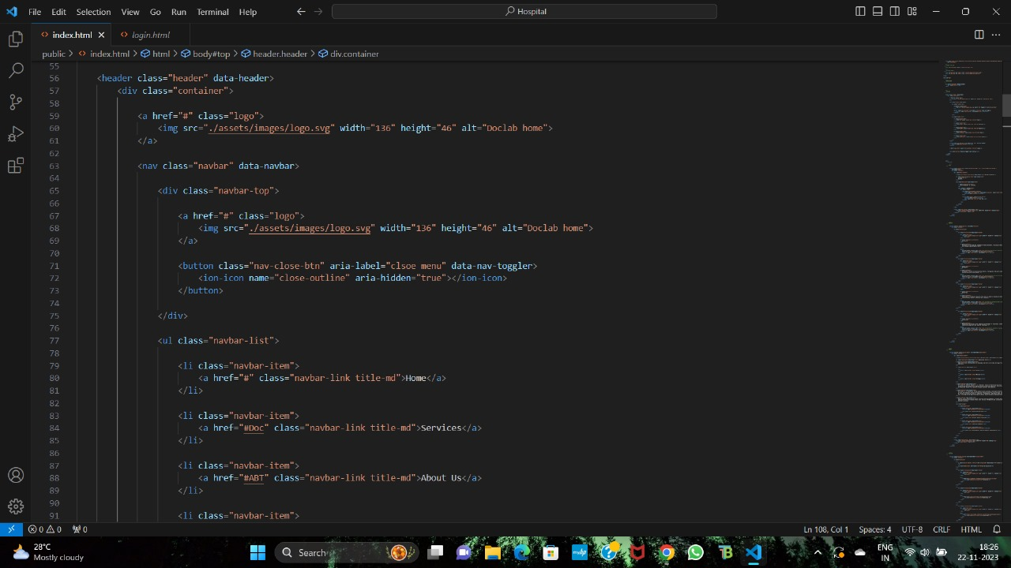

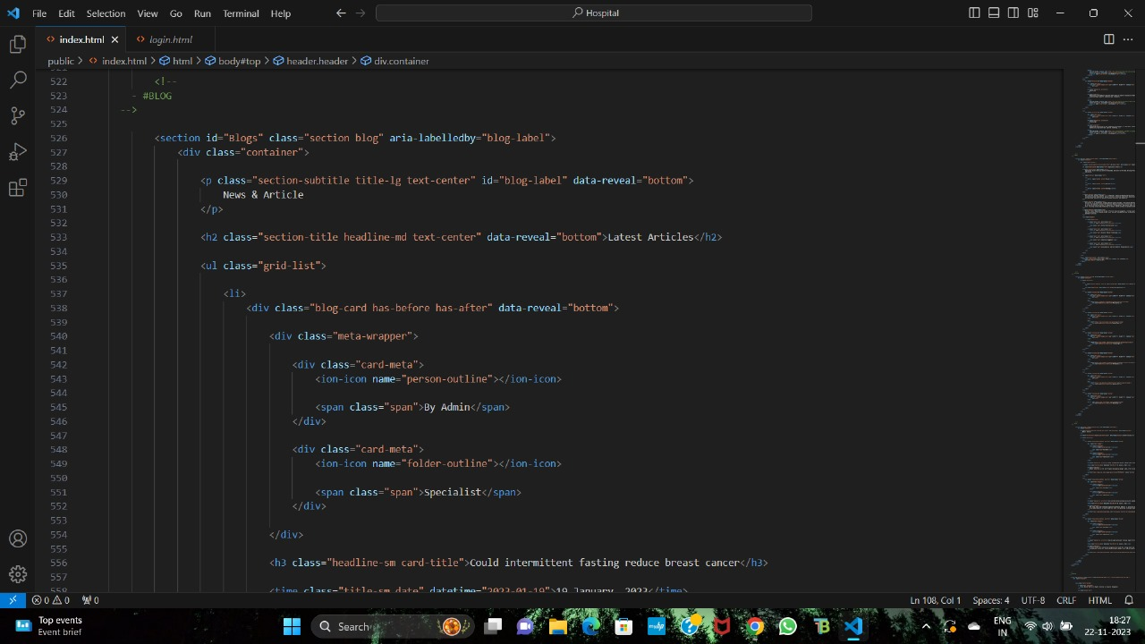

**Results**

Here are some screenshots of the Nearest Hospital Management System developed as part of this project. These screenshots showcase the key features and functionalities of the system and provide visual evidence of its successful implementation. Through the development process, we have ensured that the system meets the requirements and objectives that were identified during the planning phase. These screenshots show the search hospital by location, admin login, admin home interface, add new user, show all hospitals, add hospital, delete hospital, and update hospital. These screenshots also demonstrate the responsiveness and ease of use of the system. Take a look at the screenshots below to get a better understanding of the Nearest Hospital Management System developed as part of this project.

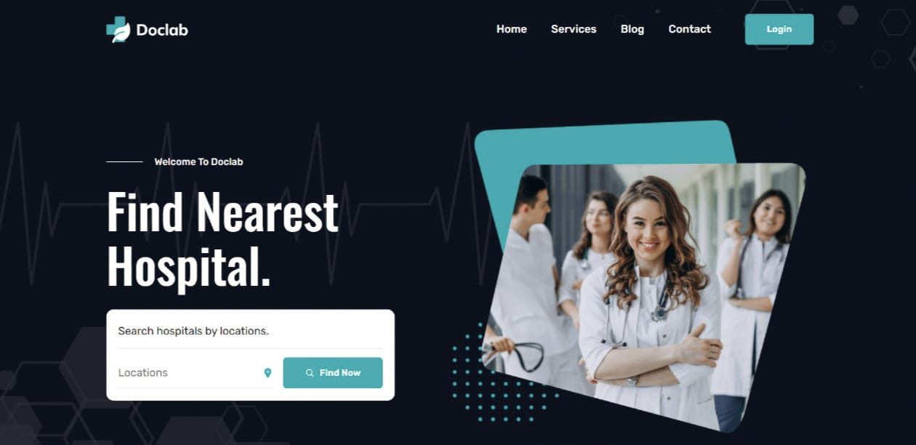

**Fig 5.1. Search Hospitals by Location**

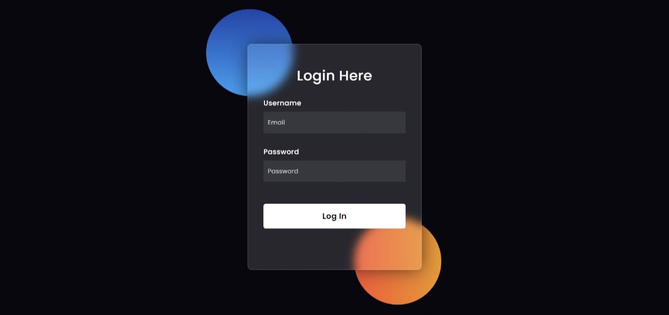

**Fig 5.2. Admin Login**

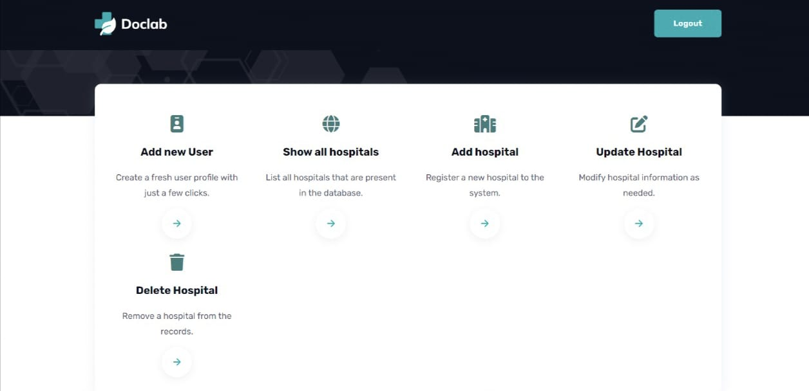

**Fig 5.3. Admin Interface**

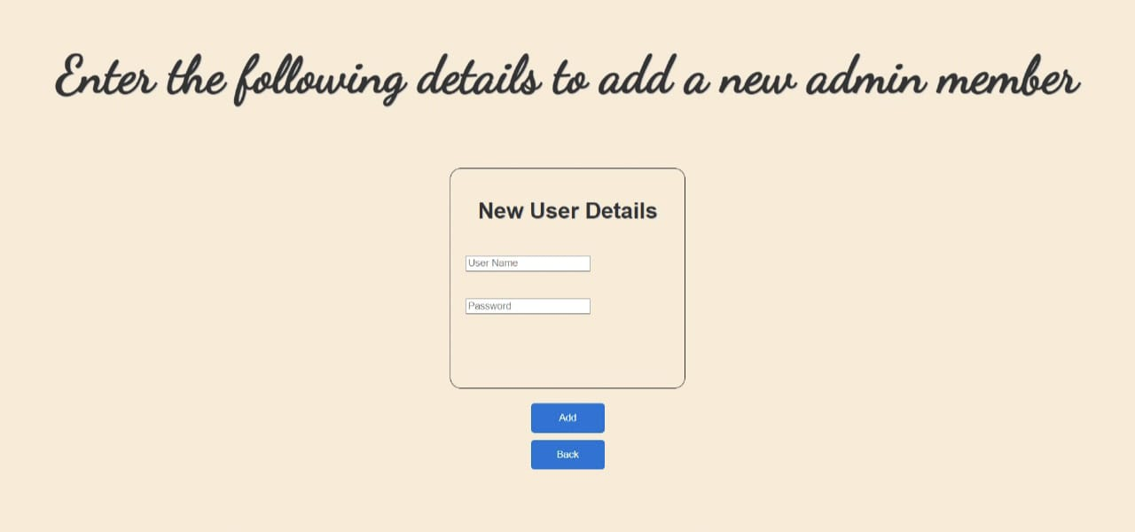

**Fig 5.4. Add New User**

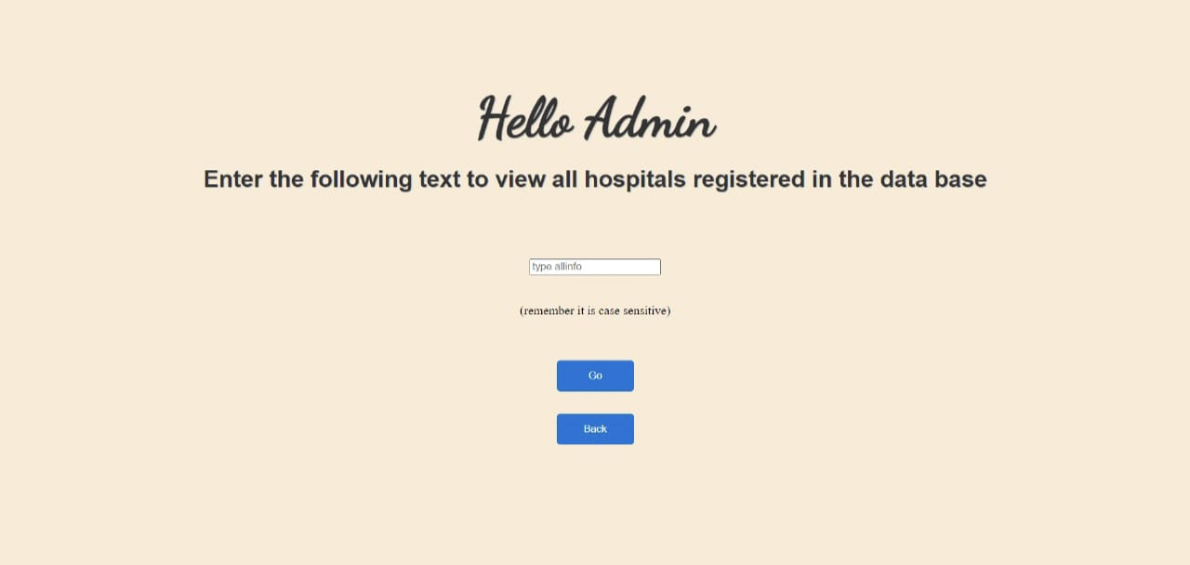

**Fig 5.5. Show All Hospitals**

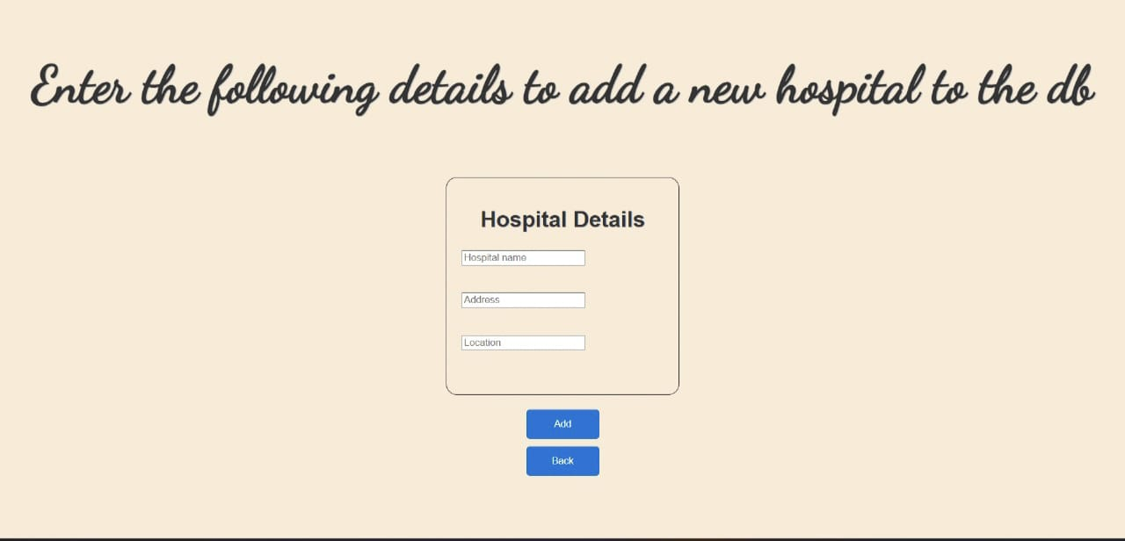

**Fig 5.6. Add Hospital**

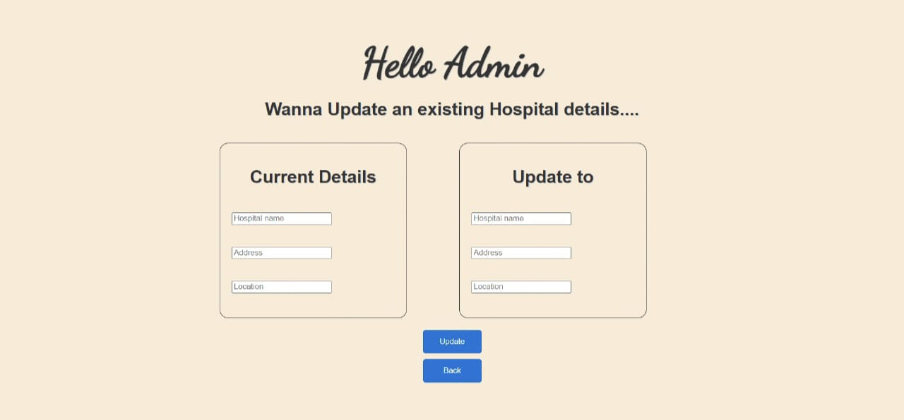

**Fig 5.7. Update Hospital**

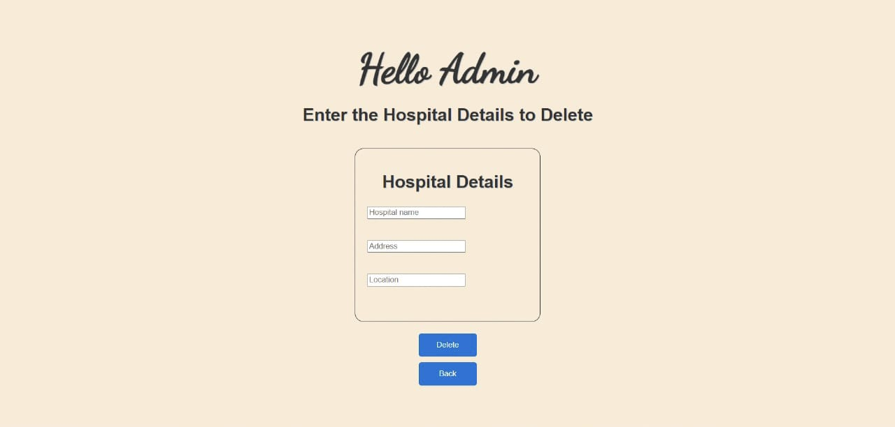

**Fig 5.8. Delete Hospital**

All these screenshots are inside the admin login and all these are handled by the admin, he can make all the changes in the database only admin have access to all these such as only an already existing admin can add a new user, can see all the hospitals and their location available in the database, add a new hospital and its current location to the database, update the hospital details if any changes are needed like location, and delete hospital details if the hospital does not exist anymore. This project mainly focuses on the admin role in the Nearest Hospital system. Patients and other users do not have access and they can only see the first page and search a hospital by giving their location and it displays all the available hospitals and address of the hospitals according to the location that is provided by the user.

**Social Impact**

The social impact of the Nearest Hospital system is significant and wide-ranging. It is a multi-faceted, influencing various aspects of community life. Efforts to address challenges and ri enhance the positive impact of healthcare systems require collaboration between healthcare providers, community leaders, and policymakers.

In the health and well-being, the proximity to a hospital allows for timely access to healthcare services, contributing to the overall health and well-being of the community. It can lead to better health outcomes, reduced mortality rates, and improved quality of life. The challenges that involved are the Socioeconomic factors, cultural beliefs, and healthcare disparities may still result in some individuals or groups facing barriers to accessing healthcare services.

A nearby hospital is crucial for emergency response, providing rapid medical attention in critical situations. This can enhance public safety and contribute to the resilience of a community in times of crisis. Emergency departments may face challenges such as overcrowding and resource limitations, impacting the efficiency of emergency response. Hospitals often engage in community outreach and education programs, promoting health awareness, preventive care, and healthy lifestyle choices. Limited resources or outreach efforts may result in some community members not being fully informed about available healthcare services.

Hospitals are significant employers in communities, providing jobs for healthcare professionals, support staff, and other related fields. This can stimulate economic growth. economic challenges within the healthcare system, such as high costs and financial strain, may impact the community and individuals. This can be centre for cultural competence in healthcare, providing services that respect diverse cultural backgrounds and needs. Cultural barriers, language disparities, and a lack of diversity in healthcare leadership can hinder effective communication and understanding.

Overall, the Nearest Hospital System built using PHP, HTML, Reactjs and CSS has a significant social impact in the hospitality industry. By streamlining operations, increasing efficiency, improving the customer experience, and potentially creating new job opportunities, this system can positively impact various healthcare providers in the industry.

**Applications**

A Nearest Hospital System could refer to a system or application designed to help individuals find the closest hospital or healthcare facility in case of emergencies or medical needs. Here are several potential applications for such a system

**Accident or Disaster Management**: During accidents or natural disasters, the system can quickly guide emergency responders and individuals to the nearest hospitals, helping them make informed decisions about where to seek medical attention.

**Disease Outbreaks**: In the event of a disease outbreak, the system could help public health officials identify and direct resources to the nearest hospitals to contain the spread and provide timely medical care.

**Ambulance Dispatch**: Emergency medical services (EMS) can use the system to dispatch ambulances to the closest hospitals, ensuring rapid response times for critical cases.

**Health Education**: The system can be part of broader health awareness campaigns, educating the public about the importance of knowing the location of the nearest hospitals for different situations.

**Virtual Consultations**: The system could be integrated with telemedicine services to connect individuals with healthcare professionals when immediate physical presence at a hospital is not necessary.

**Health Monitoring**: Integration with wearable devices could enable the system to provide personalized health recommendations and direct users to the nearest hospital if an urgent health issue is detected.

**Epidemiological Studies**: Aggregated and anonymized data from the system could be used for epidemiological studies, helping researchers understand patterns of health issues in different regions.

**Tourists' Health Services**: For travellers in a new location, the system can help them locate the nearest hospitals in case of medical emergencies or health issues.

Implementing a nearest hospital system requires careful consideration of privacy, security, and data accuracy to ensure its effectiveness and reliability in critical situations.

**Conclusion**

In conclusion, a Nearest Hospital System serves as a vital tool in enhancing public health, emergency response, and healthcare accessibility. By providing real-time information about the closest hospitals and healthcare facilities, this system plays a crucial role in improving the efficiency and effectiveness of various aspects of the healthcare ecosystem. The applications of such a system range from emergency response and public health planning to routine medical visits and specialized care.

The system's ability to integrate with technologies such as telemedicine and wearable devices further expands its utility, offering a comprehensive approach to healthcare navigation. Additionally, the data generated by the system can contribute to valuable insights for healthcare administrators, policymakers, and researchers, aiding in resource allocation, epidemiological studies, and community health awareness.

To maximize the impact and success of a nearest hospital system, it is essential to prioritize considerations such as privacy, security, and data accuracy. Implementing robust safeguards ensures the reliability of the information provided and instils confidence in users, whether they are individuals seeking immediate medical assistance or emergency responders making critical decisions in crisis situations.

As technology continues to advance, the integration of innovative features and seamless collaboration with other healthcare systems will further enhance the capabilities of nearest hospital systems. Ultimately, these systems contribute to creating a more responsive, informed, and interconnected healthcare infrastructure that prioritizes timely and efficient access to medical services for individuals and communities.

**References**

1. Malik A. (2009). RTLS For Dummies. Wiley Publishing, Inc, Indianapolis, Indiana. [Google Scholar]

2. D’Souza I, Ma W, Notobartolo C. (2011). Real-Time Location Systems for hospital emergency response. IT Professional,13(2):37–43. [Google Scholar]

3. Costs Tags-low H, High Medium (2009). Real Time Location Systems, Clarinox Technologies Pty Ltd. [Google Scholar]

4. Sepehri MM, Vahdat D, Mollabagher M. (2011). Designing of business information needs system of patients with improved health care in the surgical process using RFID technology Ministry of Science, Research and Technology. Thesis: Payam Noor University of Tehran, 1. [In persian] [Google Scholar]

5. Hong JY, Suh EH, Kim SJ. (2009). Context-aware systems: A literature review and classification. Expert Syst Appl,36(4):8509–22. [Google Scholar]

6. Ma XY, Yang K, Brayley K. (2011). RTLS-based Ubiquitous Healthcare Management System Design and Implementation. White paper in RFID Journal. [Google Scholar]

7. Carrasco VN, Jackson SS. (2010). Real time location systems and asset tracking: new horizons for hospitals. Biomed Instrum Technol, 44(4):318–323. [PubMed] [Google Scholar]

8. Boulos MNK, Anastasiou A, Bekiaris E, Panou M. (2011). Geo-enabled technologies for independent living: examples from four European projects. Technol Disabil, 23(1):7–17. [Google Scholar]

9. Harrop P, Holland G, Das R. (2017). RFID Knowledge base Case Studies. https://www.idtechex.com/research/reports/rfid_knowledgebase_case_studies_000009.asp

10. Banchs A, Serrano P, Vollero L. (2010). Providing service guarantees in 802.11e EDCA WLANs with legacy stations. IEEE Trans Mob Comput, 9(8):1057–1071. [Google Scholar]

11. Tzeng SF, Chen WH, Pai FY. (2008). Evaluating the business value of RFID: Evidence from five case studies. Int J Prod Econ, 112(2):601–613. [Google Scholar]

12. Ilie-Zudor E, Kemény Z, Van Blommestein F, et al. (2011). A survey of applications and requirements of unique identification systems and RFID techniques. Comput Ind, 62(3):227–252. [Google Scholar]

13. Hsu CC, Chen JH. (2011). A novel sensor-assisted RFID-based indoor tracking system for the elderly living alone. Sensors,11(11):10094–10113. [PMC free article] [PubMed] [Google Scholar]

14. Kim SC, Jeong YS, Park SO. (2013). RFID-based indoor location tracking to ensure the safety of the elderly in smart home environments. Pers Ubiquit Comput, 17(8):1699–1707. [Google Scholar]

15. Pope B. (2017). PresCare Deploys AeroScout Wi-Fi RFID Solution for Patient Safety and Medical Alerting. Business Wire, A Berkshire Hathaway Company. http://www.businesswire.com/news/home/20070716005284/en/PresCare-Deploys-AeroScout-Wi-Fi-RFID-Solution-Patient

16. Bacheldor B. (2007). Belgium hospital combines RFID, sensors to monitor heart patients. University Hospital of Ghent. RFID Journal. https://www.rfidjournal.com/articles/view?3120 [Google Scholar]

17. Lewis P. (2007). AeroScout Wins Innovative European Healthcare Project for Patient, Staff and Asset Tracking. Business Wire (a berkshire hathaway company). https://www.eleconomista.es/empresasfinanzas/noticias/229350/06/07/AeroScout-WinsInnovative-European-Healthcare-Project-for-Patient-Staff-and-Asset-Tracking.html [Google Scholar]

18. Bacheldor B. (2008). BlueTag Patient-Tracking Comes to North America. RFID Journal. https://www.rfidjournal.com/articles/view?3906 [Google Scholar]

19. Manzoor A. (2016). RFID applications in healthcare-state-of-the-art and future trends. Maximizing healthcare delivery and management through technology integration: IGI Global, 184–206. https://www.igi-global.com/chapter/RFID-applications-in-healthcare-state-of-the-art-and-future-trends/180652?camid=4v1

20. Oztekin A, Pajouh FM, Delen D, Swim LK. (2010). An RFID network design methodology for asset tracking in healthcare. Decis Support Syst, 49(1):100–109. [Google Scholar]

21. Alemdar H, Ersoy C. (2010). Wireless sensor networks for healthcare: A survey. Computer Network, 54(15):2688–2710. [Google Scholar]

22. Vilamovska AM, Hatziandreu E, Schindler HR, et al. (2009). Study on the requirements and options for RFID application in healthcare. RAND technical report. https://www.rand.org/pubs/technical_reports/TR608.html

23. Mackenzie CF, Wang Y, Hu PF, Chen SY. (2014). Automated prediction of early blood transfusion and mortality in trauma patients. J Trauma Acute Care Surg,76(6):1379–1385. [PubMed] [Google Scholar]

24. Delen D, Erraguntla M, Mayer RJ, Wu CN. (2011). Better management of blood supply-chain with GIS-based analytics. Ann Oper Res,185(1):181–193. [Google Scholar]

25. Wessel R. (2006). German Clinic Uses RFID to Track Blood. RFID Journal web news. https://www.rfidjournal.com/articles/view?2169/2 [Google Scholar]